## horizontal line

CNN Architecture

09.04.2025

[lenet_architecture](https://colab.research.google.com/drive/1H3irmFf-AoI7HIJbXZgYcSU_gcSbvmpQ#scrollTo=F_zI3c0u58dv)

# Basic CNN Architecture

# 

LENET-5 will be the first CNN architecture as the foundational base.

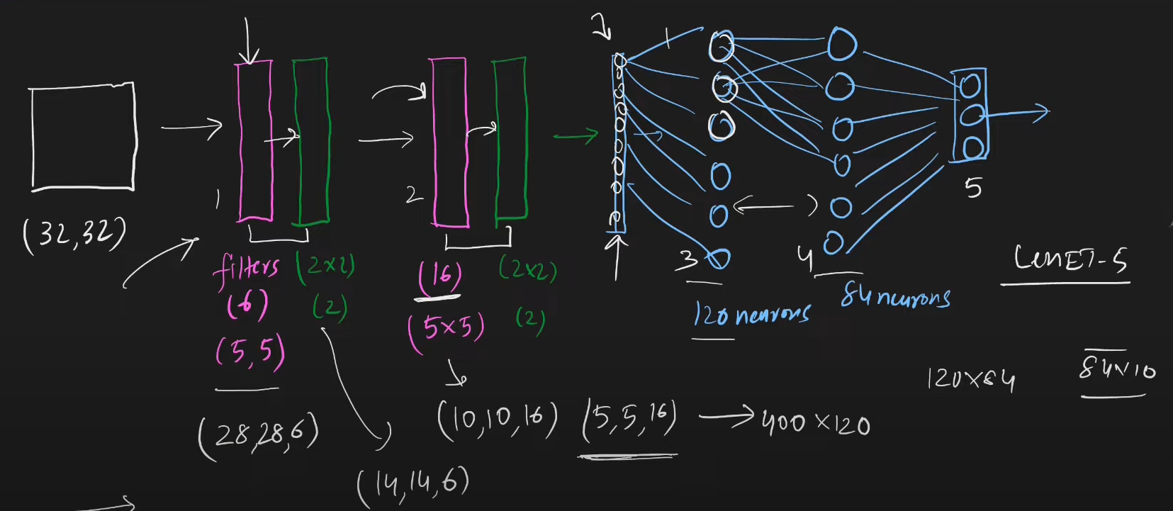

# ANN Vs CNN

## Similarities :

Node of hidden layer in ANN and filter of CNN are similar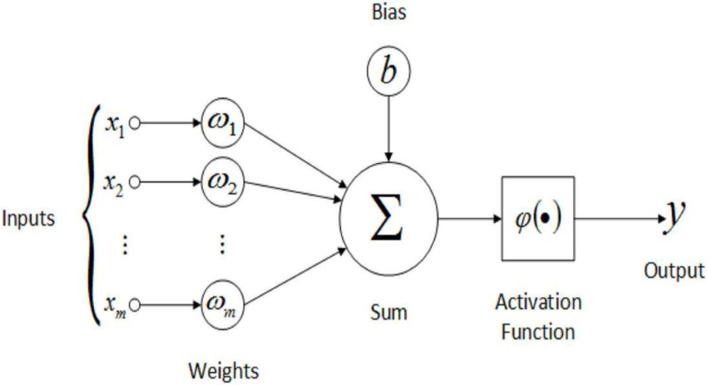

At each node you are doing W1X1 + W2X2 + W3X3_ _ _ _ _ WnXn + bias

And send it to the activation function relu.

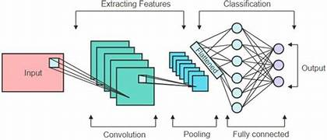

Similarly in CNN at each filter there are multiple weights (trainable parameters) that convolve. E.g. 3X3x3 filter takes 27 inputs from a receptive field 3X3X3 and its like w1X1 + w2X2_ _ _ _w27X27 + bias (of each filter) and send it to activation function relu , so how we get the first value of resultant feature map.

## Differences :

In a CNN input size doesn’t matter, it is just the filter size while in ANN as the size of input increases, trainable parameters increase.

CNN

(228 X 228 X 3) * (3 X 3 X 3)(50 filters)—--> total 1400 trainable parameters

(1080 X 1080 X 3) * (3 X 3 X 3)(50 filters)—--> total 1400 trainable parameters

ANN

784 inputs —-> w1x1 + w2x2 + _ _ _ _ _ _ _ w784x784

1080 inputs —-> w1x1 + w2x2 + _ _ _ _ _ _ _ w1080x1080 trainable parameters increase